|  |  |
| --- | --- |
| EGC_Black | Student Name \_\_\_\_\_\_\_\_\_\_\_\_\_\_\_\_\_\_\_\_\_\_\_    **Eastern Goldfields College**  Mathematics Essential Units 3 & 4 2018  Test 11 |
| **Working Time: 15 minutes** | **Total Marks: 19 marks** |

**Calculator Free (No notes or calculator allowed)**

**Question 1** [2 marks]

For the following items state whether you would be required to calculate the length, area, surface area, volume or capacity.

1. The amount of metal in a steel ball bearing.
2. The amount of carpet needed to carpet a house.
3. The amount of cordial that can fit into a particular jug?
4. The distance around a race track.

**Question 2** [2 marks]

Calculate the area:

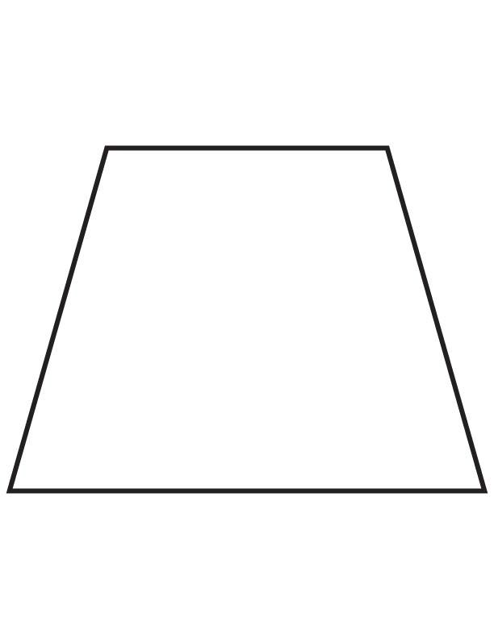

6cm

12cm

8cm

**Question 3** [2 marks]

Calculate the volume of the following shape:

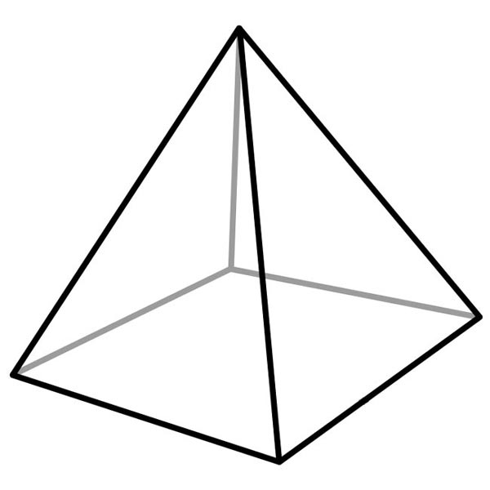

2 cm

3 cm

3 cm

### Question 4 [5 marks]

**Circle** the correct answer in each of the following:

a) 2.15 km converts into how many metres?

(i) 21.5 m (ii) 215 m (iii) 2150 m (iv) 21500 m

b) 250 L converts to how many ml?

(i) 250 ml (ii) 2500 ml (iii) 0.25 ml (iv) 250000 ml

c) 1 m2 converts to how many cm2?

(i) 100 cm2 (ii) 10 000 cm2  (iii) 100 000 cm2 (iv) none of these

d) 5.4 cm2 converts to how many mm2?

(i) 540 mm2  (ii) 5400 mm2 (iii) 54 mm2 (iv) none of these

e) 15 m3 has a capacity of how many Litres?

(i) 1500 ml (ii) 15 L (iii) 15 000 L (iv) 150 000 ml

### Question 5 [3 marks]

How much fencing is needed to completely fence in the paddock?

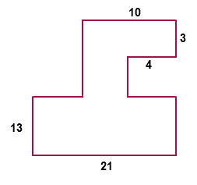

100m

30m

70m

30m

100m

30m

Give answer in km

### Question 6 [5 marks – 3, 2]

1. Calculate the surface area of the box below. Show all working.



1. If canvas paper costs $3 per square metre, how much would it cost to cover the box?

|  |  |
| --- | --- |
| EGC_Black | Student Name \_\_\_\_\_\_\_\_\_\_\_\_\_\_\_\_\_\_\_\_\_\_\_    **Eastern Goldfields College**  Mathematics Essential Unit 3 2017  Test 21 |
| **Working Time: 40 minutes** | **Total Marks: 36 marks** |

**Calculator Assumed (Formulae sheet and one A4 page of notes)**

**Question 7** [3 marks]

Find the shaded area. Give your answer to one decimal place.



**Question 8** [3 marks]

Calculate the perimeter of the shape below

6.5 m

### Question 9 [7 marks – 3, 2, 2]

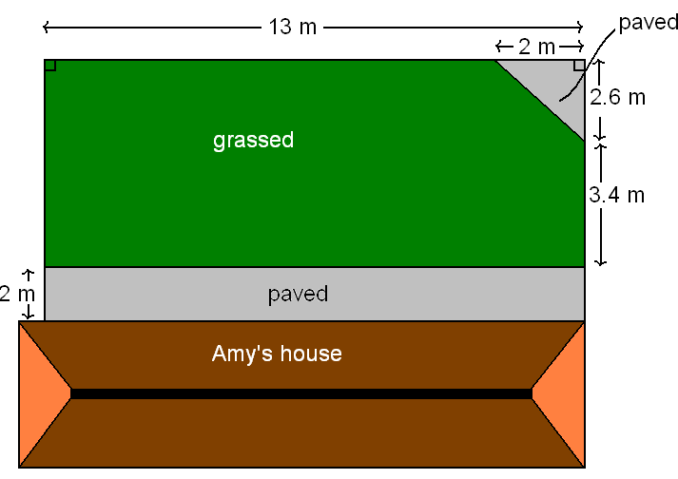Here are the plans for Amy’s backyard. She wishes to pave part of it and have grass for the rest.

**a)** What is the total area of the paved sections?

**b)** What is the total area of the grassed region?

**c)** Amy wants to fence her back yard (not including the distance along the house). Calculate the total length to be fenced.

**Question 10** [4 marks]

The figure below consists of a cube with a square pyramid placed on top.



The side length of the cube is 8 cm. The square pyramid has a height of 3 cm and a slant height of 5 cm.

Determine the total volume of this figure.

**Question 11**  [5 marks – 3, 2]

A **choctop cone** is a favourite with movie-goers. The cone is full of ice-cream and has a scoop of ice-cream on top in the shape of a hemisphere which is covered in chocolate as shown below. (\*Just the hemisphere has a chocolate coating)

1. What is the total volume of ice-cream? (Round answer to one decimal place)

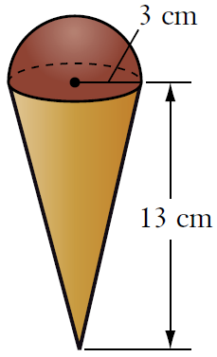

1. What surface area is covered with chocolate? (Round your answer to the nearest whole number)

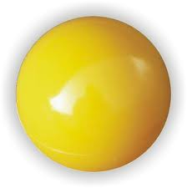**Question 12** [4 marks]

A gas company stores gas in spherical tanks.

The diameter of each spherical tank is 8.32 m to the nearest cm.

The volume of one tank has been calculated as 2412.45 m3

using the formula below. One of their employees queries the

volume obtained.

Is he justified? Explain and recalculate if necessary.

V = π × 8.323

= 2412.45 m3

**Question 13** [6 marks]

A farmer needs a new rain tank for his house out on the farm. He is offered the tank

below from a fellow farmer. If the rain collected on average is 1.1L per day, is the

tank big enough for the 91 days of winter? (Assume that he does not empty the tank

during this time). Justify with calculations



3.5m

**Question 14** [4 marks – 3, 1]

Consider the solid prism of length 30 cm shown in figure 1. The prism has a square cross-section with a quarter of a circle removed from the top right corner, as shown in figure 2. The square has a side length of 8 cm and the radius of the circle is 4 cm.



(a) Show that the area of the cross-section shown in Figure 2 is 51.43 cm2, rounded to two decimal places.

(b) Calculate the volume of the solid prism shown in Figure 1.

END OF TEST